Date: August 08th, 2019

Head Office

No. 175ABCD, Mao Tse Tong Blvd.,

Sangkat Toul Svay Prey 1, Khan Chamkarmon,

Phnom Penh City, Kingdom of Cambodia

Email: sreyvoat@princebank.com.kh

Dear Sir or Madam,

I am interested in applying for a job in post of **Business Relationship Manager** with your company due to my long experience over twelve years in banking industry.

Presently, I am a Credit Analysist Manager in Business Development Department with MGN Emperor Bank. My role is focusing on credit assessment process for management approval. The MGN Emperor Bank is a new bank in Cambodia and its soft opening was granted since July 07th, 2019 coming while I have started my work since April 01st, 2019.

I would like to work with PRINCE Bank due to its version and mission to be a lending commercial bank which support the Cambodian’s financial by offering loans to Cambodian people for all levels.

Subject to my long experience in loan process (write up) with my previous bank, RHB Indochina Bank, almost 4 years and Vattanac Bank for over 2 years. Though, I clearly understand about credit marketing and assessment for new and existing loan portfolio and assist my supervisor in planning, organizing, and controlling the operations of the credit section with discretion necessary to fulfill the Bank’s goals and policies, guidelines, and instructions.

I also have experience and understanding on the bank’s products and services during my employment in ACLEDA Bank for more than 6 years with multi-function of duty related to Deposit (Saving, Current, and Fixed Deposit account), Money Transfer Service (by Swift and Western Union), Electronic Banking Service (ATM, VISA, Mobile/Internet Banking), Trade Finance, Credit, etc. Moreover, I also was an authorizer in Banking System on my last position as Deputy Chief Marketing Officer there.

According to my long term experience in banking service industry for almost twelve years, it has taught me how to meet and exceed each customer's expectations with service that sells. I have assisted all types of customers in all types of settings for customers. And I am surely qualified to fit your criteria with this position.

To strengthen my ability in career, I would like to apply for a job with PRINCE Bank to grow and learn more with new experience and environment.

It would be a pleasure to interview with you and I look forward to hearing from you soon.

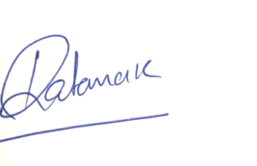Best Regard,

Sok Ratanak

Encs CV

**Mobile: 092 700 005**